A Proposal To GS1 US

A Device to Measure and Analyze
High Precision, NIST Traceable,
Matrix Symbology Test Targets

Proposal Jointly Submitted By:
Quality Engineering Associates, Inc. |  |  |  | Pitney Bowes, Inc.
Burlington, MA 01803 USA |  |  |  | Shelton, CT 06484 USA
Dr. Ming-Kai Tse, President |  |  |  | Dr. Claude Zeller, Principal Fellow,  Dr. Robert Cordery, Principal Fellow
Date: May 11, 2007 |  |  |  | Date: May 11, 2007

Table of Contents
Proposing Organizations and Contacts 4
1. Technical Proposal 5
1.1. Overview 5
1.2 Equipment and Software 7
1.3 Functional Descriptions (Mandatory and Extended Functions) 13
1.4 Acceptance and Conformance Tests 19
1.5 Calibrated Conformance Test Targets (CCTT) 19
2. Organization and Qualifications 20
2.1 Quality Engineering Associates (QEA), Inc. 20
2.2 Pitney Bowes 21
2.3 Key Personnel and Specific Expertise 21
3.0 Price Proposal 23
Appendix A 24

Background

This proposal is submitted in response to a Request for Proposal (RFP) announcement by GS1 US on April 12, 2007. The Background section is largely quoted from the RFP Introduction in order to provide a clear overview of the project.
GS1 US has initiated a program to design, build and deploy a device to measure and analyze high precision matrix symbology test targets (the so-called Calibrated Conformance Test Targets, CCTT). The CCTTs are engineered to provide NIST traceable measured values for use in the calibration of bar code symbol verification equipment to a precise standard. There is currently a device in operation that performs a similar function for linear bar code symbol targets. The intent of this program is to develop an analogous device for the measurement (calibration) of two-dimensional symbologies, in particular Data Matrix symbols. Implementation is expected to move forward in a phased approach. The current RFP Proposal (RFP) specifically addresses all requirements related to implementation of Phase 1 implementation and all hardware required for implementation of Phase 2. The four phases of this program are:
Phase 1: Device capable of calibrating “conventional” printed Data Matrix Calibrated Conformance Test Targets (CCTT). It is the desire of GS1 US to complete this Phase before the end of 2007.
Phase 2: Device capable of calibrating Direct Part Marking (DPM) Data Matrix CCTT. The goal is to complete this by mid 2008.
Phase 3: Device capable of replacing or backing up the existing linear symbology calibration device.
Phase 4: Develop expanded capabilities to include other one-dimensional and two-dimensional symbologies, as needed.
To insure open system access to and quality control for this device and the existing linear device, GS1 US will continue to administer operational, maintenance and auditing of the current 1-D and proposed 2-D devices.

Proposing Organizations and Contacts
Quality Engineering Associates (QEA), Inc. and Pitney Bowes jointly submit this proposal. The Principal Investigators and Cost Proposal Contacts Information are as follows:

Quality Engineering Associates (QEA), Inc.
99 South Bedford Street, #4
Burlington, MA 01803 USA
Tel: 781-221-0080
Fax: 781-221-7107
www.qea.com

Principal Investigator (Technical) | Dr. Ming-Kai Tse, President  (mingkaitse@att.net)
Co-Principal Investigator (Technical) | David Forrest, VP, Engineering (dforrest@qea.com)
Cost Proposal Contact | Ananna Tse, VP, Finance and Administration (ast@qea.com)

Pitney Bowes, Inc.
35 Waterview Drive
Shelton, CT 06484 USA
Tel: 203-924-3524
Fax: 203-924-3442
www.pb.com

Principal Investigator (Technical) | Dr. Claude Zeller, Principal Fellow (czeller@ieee.org)
Co-Principal Investigator (Technical) | Dr. Robert Cordery, Principal Fellow (robert.cordery@pb.com )
Cost Proposal Contact | Gary Hansen, Director, Physical Sciences  (gary.hansen@pb.com)

- Technical Proposal
  - Overview
This proposal is jointly submitted by Quality Engineering Associates (QEA), Inc., Burlington, MA and Pitney Bowes, Shelton, CT in response to the GS1 RFP (April 12, 2007) which outlines the requirements for a measuring device (the “Device”), which consists of a high resolution imaging system (the “System”) and associated analysis software (the “Judge”). The “Device” will be used to calibrate test targets known as Calibrated Conformance Test Targets (CCTT) for two dimensional matrix symbols. QEA will be responsible for the “System” and Pitney Bowes for the “Judge”. Both companies will be responsible for the integration of the overall “Device”.
The Device will be designed to mimic the measurement methodology of typical commercial verification devices and have national standard traceable performance as specified below. The device will have demonstrable repeatability and accuracy, and is targeted to achieve accuracy and repeatability ten times better than the conformance specifications for commercial verification devices in ISO/IEC 15426-2. The “System” will consist of a high resolution imaging system and automatic target loading/unloading. The “Judge” will be developed in accordance with ISO/IEC 15415 and ISO/IEC 16022. The “Judge” will also be publicly-reviewable image analysis software.
The effective resolution of the measuring device will be at minimum 20, and preferably 30 image pixels per module in each axis (x and y). In the case of a Data Matrix symbol with
X = 0.006 inch this corresponds to a minimum resolution of 3333 pixels/inch and a preferred resolution of 5000 pixels/inch.
Measurement of reflectance will be calibrated against a NIST traceable standard reflectance target. Measured values of R_{max} and R_{min} will be accurate to ± 0.5% reflectance and repeatable to within ± 0.3% reflectance. Note that these accuracy and repeatability specifications differ from those in the RFP as explained in further detail in section 1.2 of this document.
Measurement of dimension will be calibrated against NIST traceable Ronchi scale (chrome on glass rule). Measured values shall be accurate to ± 0.0005 inch (12.7µm) and repeatable to ± 0.0005 inch (12.7µm).
Acceptance Tests for the “System” and Conformance Tests for the “Judge” and associated acceptance criteria will be developed and agreed upon by QEA, Pitney Bowes and GS1 prior to the commencement of this project.
Appropriate Calibrated Conformance Test Targets need to be supplied by GS1 for development purposes. QEA and Pitney Bowes will be available for providing suggestions and advice from the instrumentation and measurement point of view.
A jury of technical experts, appointed by AIM TSC, will determine that the Device meets the requirements of the RFP if it performs the functions defined in the mandatory function section of the RFP and if the results of measurements of Calibrated Conformance Test Target symbols, carried out in accordance with ISO/IEC 15415, demonstrate that the reported parameters are within the tolerances stated.
The targeted lead time is 6 months. The success in meeting this aggressive delivery target hinges on close collaboration with GS1 and the proposing organizations, e.g., contract negotiation, definition of acceptance and conformance tests and criteria, availability of CCTTs for development and testing, and timely input/critiques by the TSC team.
The proposed “System” is “Phase 2 ready.” While specific light source for Direct Part Marking application is not provided in this proposal, the “System” is designed to be adaptable to the Phase 2 application. QEA has experience in analyzing DPM symbols, in addition to an existing product line to measure similar parts (e.g. flexographic printing plates).

1.2 Equipment and Software

In this proposal:
- QEA will provide items 1-7 and 9-11 (the “System”); and Pitney Bowes will provide item 8 (the “Judge”).
- QEA and Pitney Bowes will jointly integrate the “System” and the “Judge” into the “Device”.
Item | Description | Quantity | Deliverables | Exceptions &  Qualifications
1. Platform (base) | A platform that will provide a stable surface for mounting of the device components apart from any peripheral devices such as the computer, log printer, label printer, etc. Commercially available optical bench or custom made for the application. | 1 each | - A commercially available optical bench to provide a stable support for the main instrumentation including the imager, the illumination source, X-Y table and the target feeding system (i.e., an ADF or automatic document feeder).  - The PC and peripherals will be located apart from the optical bench and main instrumentation.
2. Computer | Stand alone unit with appropriate interface for operation of the measuring engine. The computer shall have the capacity to record, for archiving purposes, to CD or some other storage device. The unit shall include separate keyboard, monitor and printer. | 1 each | - A desktop (or tower) PC with sufficient processing speed, memory, and hard drive capacity, CD/DVD, keyboard, monitor, a log printer and a label printer.
3. Imager | Camera system consisting of high resolution b/w imaging array and lens system. | 1 each | - A 16 megapixel monochrome camera with high quality optics to provide up to 5000dpi spatial resolution. This corresponds to ~30 image pixels per module.  - 12 bit bit-depth to provide good grey scale resolution  - Camera-link or a comparable interface. | - At 5000dpi, the maximum field of view is ~24.5 mm x 16.5 mm.

4. Illumination Source | One or more lighting configurations in accordance with Annex D of ISO/IEC 15415 and section 6.2 of AIM DPM-1-2006 (Phase 1 + Phase 2 configuration). | 1 each | - An appropriate light source in accordance with Annex D of ISO/IEC 15415 for the Phase 1 configuraton.  - An appropriate fixture to accommodate the lighting configurations in accordance with section 6.2 of AIM DPM-1-2006 Guideline (for Phase 2).  - An enclosure to provide a controlled environment for the imaging system. | - To lay the foundation for Phase 2, an appropriate fixture will be provided to accommodate the various lighting geometries described in the AIM DPM Guideline.
5. Platform (measuring) | A platform, to be mounted to the “base”, that will provide positioning capability for the measurement of the calibration targets. The measuring platform shall be capable of positioning from 0 to 10 inches, in both x and y axis and to have a least count (resolution) of 0.01 inch in both x and y axis. In addition, the platform shall be capable of rotating the target through 360 degrees. The rotation component of the platform shall be able to rotate the target from 0 to 360 degrees with a least count of one half degree. The measuring platform shall include a “hold down” system for the calibration target. The hold down system may be vacuum, magnetic or some other technique. | 1 each | - A computer controlled X-Y table for positioning the calibration target; range is 0 to 10 inches in both x and y axis.  - The positioning resolution will be 0.01 inch (254µm) in both x and y axes.  - An appropriate hold-down mechanism for the sample.  - To ensure that the automatic target feed system (see 6) works smoothly with the X-Y table and the sample hold-down mechanism, the rotation mechanism will be integrated with the camera-illumination module (instead of the X-Y table).  - The rotation component will be able to rotate from 0 to 360 degrees with a least count of one half degree. | - The X-Y table will accommodate a maximum sample size of letter or A4 size.  - The rotation mechanism will be integrated with the camera-illumination module instead of the X-Y table.

6. Target Feed System | Automated system, controlled by the application interface, to allow automatic sequential feed, positioning and removal of multiple test targets from the device. | 1 each | - An automatic document feeder (ADF) will serve as the target feed system to allow automatic sequential feed, positioning and removal of multiple test targets. | - Note that since the CCTT (Calibrated Conformance Test Target) will be in direct contact with the ADF mechanism, there is always a potential of some minor damage to the target. The design and material choice for the CCTT should take this potential into consideration.
7. Calibration Targets | Targets, used to calibrate the device, shall be NIST traceable. | 1 lot | - A target for reflectance calibration (tone scale or similar target). The reflectance accuracy and repeatability are ±0.5% and ±0.3% respectively.  - A Ronchi ruling for spatial calibration. The spatial accuracy and repeatability are ±0.0005 inch (12.7µm) and ±0.0005 inch (12.7µm) respectively. | - ISO/IEC 15426-2 specifies a tolerance of ±5% for R_{max} and ±3% for R_{min} for bar code verifier conformance (section 2). We believe a 10X improvement in reflectance tolerance is reasonable and sufficient for this Device.
8. Application Software (the “Judge”) | Image analysis (as specified by ISO/IEC 15415 for Data Matrix – Phase 1), reporting and archiving software. The source code for the application software shall be written in C language. | 1 lot | - The “Judge” – image analysis software as specified by ISO/IEC 15415 for Data Matrix – Phase I.  - The source code (and the programming language) for the application software will be “reviewable” and “maintainable” by a competent software developer.  - The reporting and archiving functions will be provided by the measurement software (see 9) | - As detailed in this proposal, the application software will be written in MATLAB callable from a Dynamic Linked Library (dll) written in C or C++ that integrates with the measurement software (9) and user interface software (11).

9. Measuring Software | Device drivers, image capture, calibration and maintenance routines necessary to obtain NIST traceable data for the analysis (“Judge”) software | 1 lot | - Measurement software will be provided to control image acquisition, calibration, and maintenance routines necessary to obtain NIST traceable data for the analysis (“Judge”) software.  - The captured image will be passed onto the Image Analysis Module (The “Judge”, see 8 below) for analysis, which in turn will pass the analysis results back to the measurement software for on-screen reporting and archiving.  - NIST traceable reflectance and spatial calibration targets will be included with the system.  - Spatial accuracy and repeatability will be ±0.0005 inch (12.5µm).  - Reflectance accuracy will be ±0.5% and repeatability will be ±0.3%.
10. Utility Software | Operating system, compiler (s), translation (native language to C language) | 1 lot | - XP Professional operating system  - Microsoft Office Professional (including Excel spreadsheet and Access database application software).  - MATLAB computational software
11. User Interface Software | Program to control the “automated” process of making measurements and reports. | 1 lot | - Control software with an appropriate, easy-to-use interface to enable automated measurements and reporting.  - Control software includes a powerful yet easy-to-use sequence editor for the user to define a test sequence with multiple regions-of-interest (ROI) in a test sample.

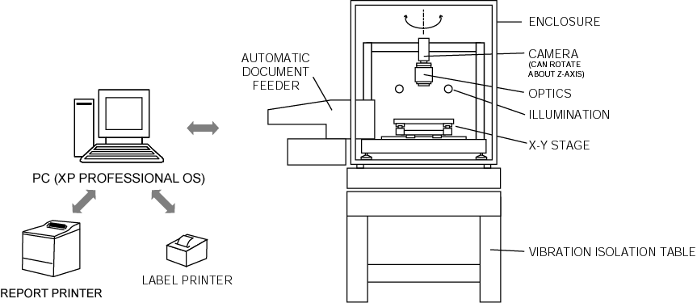
Fig. 1a. System Hardware Schematics.

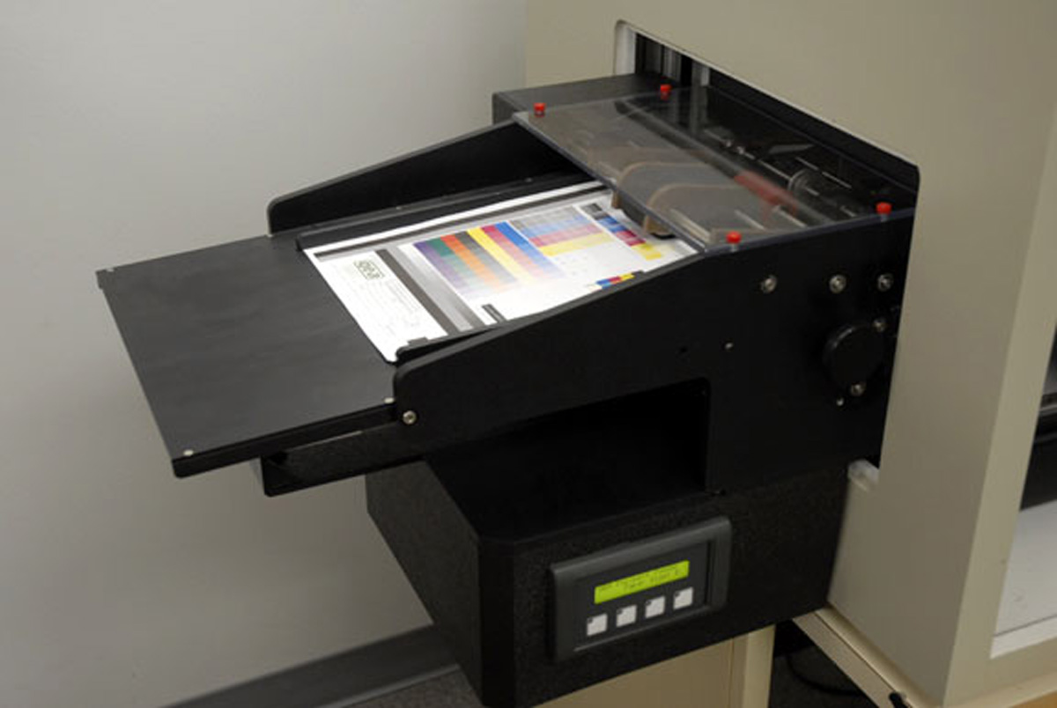
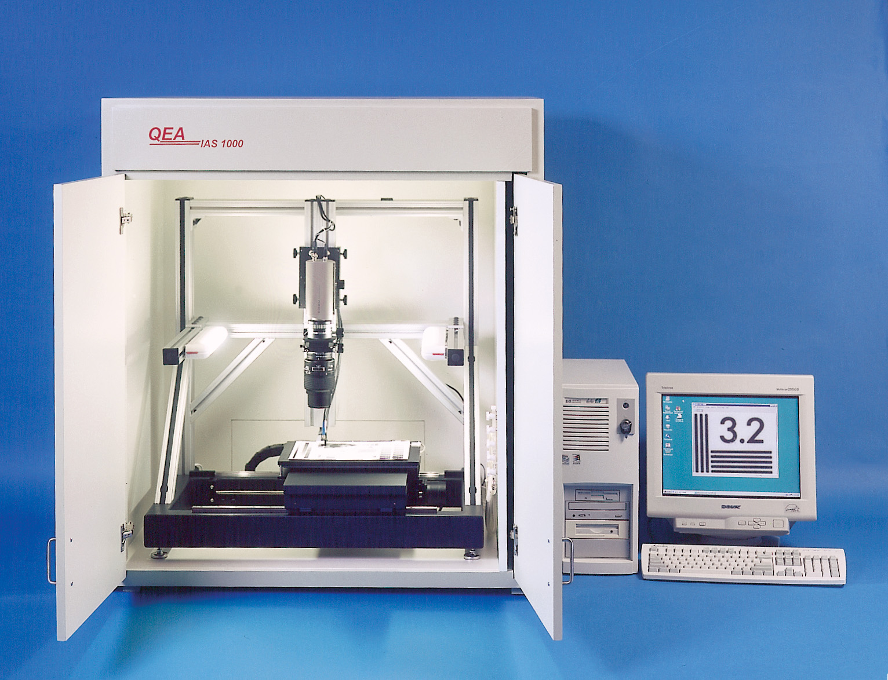
Fig. 1b. The ADF (Automatic Document
Feeder) designed for the IAS-1000. A similar design is proposed for the “System”.
Fig. 1c. The IAS-1000 Automated Image Quality Analysis System. The IAS-1000 design will be used as the basis of the “System” proposed.

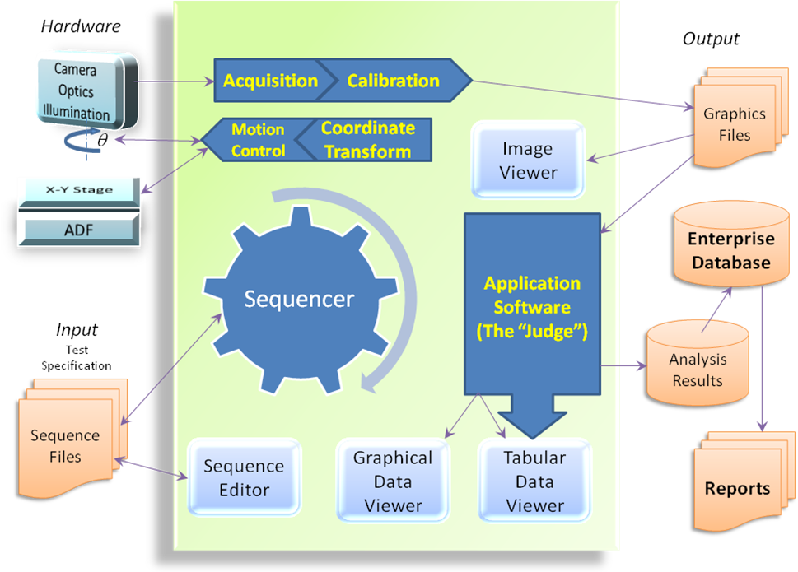
Fig. 2 Software Architecture of the “System” with the Associated “Judge” Module.

1.3 Functional Descriptions (Mandatory and Extended Functions)

The Device, consisting of the “System” and the “Judge”, is designed for measuring two-dimensional matrix symbols utilizing the methodology defined in ISO/IEC 15415. It will be capable of all the mandatory functions required in the RFP as well as a host of extended functions.

1.3.1 The “System” (QEA’s Responsibility) (see Figs. 1 and 2.)
- The loading of a test target into the System can be manual or automatic. For automatic loading (and unloading), an ADF (Automatic Document Feeder) will be used. This feature will greatly enhance the productivity of the System.
- The System will locate the target image using fiducials incorporated into the CCTT, position the target relative to the camera and optics, capture and image the test symbol from a sample area.
- To frame the test symbol and its quiet zones, and to extend for specified symbol sizes 20X beyond the quiet zones, the user must select the magnification (pixel resolution) accordingly. The user needs to balance between resolution and the size of the field of view (which in turn determines the maximum symbol size in one single frame). For example, for the System utilizing a state-of-the-art area CCD camera with 16 megapixels (~4900x3300 pixels) and high quality optics, the field of view or maximum symbol size is ~37.7mm x 25.4mm at the minimum 3333 dpi (i.e., 7.7µm/pixel) required; whereas at the preferred 5000 dpi resolution (i.e., 5µm/pixel), the field of view or maximum symbol size is reduced to ~24.5mm x 16.5mm.
- The System will be calibrated using the NIST traceable Ronchi scale provided. Measured spatial dimensions will be accurate to ±0.0005 inch (12.7µm) and repeatable to ±0.0005 inch (12.7µm)
- The accuracy and repeatability in reflectance adopted in this proposal differ from the RFP by a factor of 10. The verifier conformance specifications in ISO/IEC 15426-2 call for a precision of ±5% for R_{max} and ±3% for R_{min}, therefore, to achieve the goal stated in the RFP of “a device that achieve accuracy and repeatability ten times better than commercial verification devices”, we believe that a precision of ±0.5% (instead of ±0.05%) is sufficient for this application. The corresponding numbers in the RFP are probably unnecessarily stringent and in fact difficult to achieve using reasonably priced but good performance cameras and optics.
- The System will most likely use a 12 bit (4096 grey levels) camera. At this bit depth, the maximum resolution due to discretization is 4096 levels or 0.024%, and the resolvability of real reflectance differences is probably lower, say 0.1%. Such a camera should be able to meet a precision requirement of ±0.5% (but probably not ±0.05%).
- The illumination source and configuration will be designed to meet the Phase 1 requirements in accordance with Annex D of ISO/IEC 15415. However, the illumination fixture will be designed for future expansion, including meeting the configuration recommendations outlined in section 6.2 of AIM DPM-1-2006 for Phase 2. While no specific illumination will be provided for Phase 2 Direct Part Marking measurements, the light source supplied for Phase 1 can potentially be reconfigured and applied to meet some of the Phase 2 requirements.
- In operation of the System, the test target is first fed into the System, either manually or via the ADF. Target information will be input manually by the user or by some other automatic means (TBD). The test target is then positioned properly (including any necessary translations of the X-Y table and rotation of the theta axis) by the control software utilizing fiducials on the CCTT and a pre-programmed test sequence. The imager will then capture an image under the control of the measurement software using a gamma of one (i.e., the output pixel values will be the raw values as captured without any modification); and the image will finally be passed onto the Application Software (the “Judge”) for the image analysis.
- After completion of the analysis, the “Judge” in turn passes back to the System a set of results, which will be then reported and archived.
- Each measurement and analysis report will contain, at a minimum, the following information:
- The test environment
- CCTT serial number
- Device number
- SW version
- HW revision number
- Date and Time
- Operator
- Raw Images
- Device setting parameters
- Symbology tested
- Overall symbol grade as measured and reported by the instrument and as defined for the primary reference test symbol in question
- The values for the individually measured parameters
- On completion of the measurement process, the System will produce a label to be applied to the CCTT. The label will contain:
    - CCTT serial number
    - Reported Parameters for each symbol of the CCTT
    - Measurement Date/Time

    - The “Judge” (Pitney Bowes’ Responsibility) (see Fig. 2)
1.3.2.1 Overview
The “Judge”, i.e., the Image Analysis Application Software will be the responsibility of Pitney Bowes. The program will be written in MATLAB callable from a Dynamic Linked Library (dll) written in C or C++ that integrates with the QEA System. The dll interface will be written by QEA. The module will be developed in accordance with the specifications of ISO/IEC 15415, ISO/IEC 16022 and ISO/IEC 15426-2 for Data Matrix; and in operation:
- The “Judge” first establishes a reference grey-scale image and a binarized image as described in ISO/IEC 15415 and ISO/IEC 16022.
- These images will then be decoded in accordance with the applicable reference decode algorithm(s), ISO/IEC 16022 for Phase 1.
- The individual values and grades for each of the parameters listed in ISO/IEC 15415 and ISO/IEC 16022 will be reported:
- An overall symbol grade
- The decoded data
- The number of images on which the overall symbol grade is based
- Symbology verified
- All decoded symbol characters or codewords (both as decoded and as corrected)
- The analysis results will be passed to the System for archival purposes (by unique serial number)
As stated, the application software will follow the ISO/IEC 16022 and ISO/IEC 15415 standards explicitly for ECC 200. Additional steps will estimate the errors in measured quantities, so that the grid locations and grey levels will be reported with estimates of systematic and random errors. Some specific algorithms defined in 16022 are modified with equivalent algorithms to simplify the code, analysis and modification. For example, edges are found by grouping the pixels into objects and enumerating the boundaries, rather than tracing pixel by pixel. Other modifications are the use of spectral methods designed to increase statistical accuracy. For example, the location of the aperture to get module gray levels will be placed at the best estimate of the location rather than the nearest pixel location. In the following, the 16022 and 15415 modules are described in more detail.
1.3.2.2 The ISO/IEC 16022 Software Module
The ISO/IEC 16022 module (only ECC 200 will be implemented) will perform the following functions:
- Define measurement parameters and form a digitized image:
- Accept a raw image and image information including grading parameters that differ from their default values from the imaging system
- Set remaining parameters to default values dMin, gMax, nMin, minEdgeLength, apertureRadius
- Construct aperture with slight blurring on the edge (using spectral methods) to minimize variance due to slight variations of aperture position – or equivalently, blur the image slightly (e.g., with a Gaussian with standard deviation about 2 pixels) before applying a circular aperture. This helps achieve statistical consistency.
- Convolve the raw image with the aperture to create a reference image
- Determine in the initial (circular region), extended (large zone), and revised (based on the decode) values for R_{min} and R_{max}
- Estimate statistics for R_{min} and R_{max} (extremes of a distribution are generally noisy. Also the mean of the positions of the extremes are not necessarily related to a good choice for the threshold. Therefore, we will report the difference between the threshold defined by the AIM DPM approach and the 16022/15415 threshold.)
- Construct a binary image
- Search horizontal and vertical scan lines for the two outside edges of the Data Matrix "L":
- Separate image into objects and enumerate boundaries around each object. Use these boundaries to implement section b)
- Determine statistics of edge location accuracy

- Continue searching for "L" candidates using horizontal and vertical scan lines offset from previous scan lines:
- First assume that the candidate area contains a square symbol.
- For each of the two sides of the alternating pattern, find the line passing through the centre of the alternating light and dark modules:
- Centers will be located using the 16022 methodology and using a best grid determined by spectral methods. Statistics of centers will be estimated.
- For each side, determine the number of data modules in the side of the square symbol or data region:
- For each side, find the centre points of the alternating pattern modules:
- Calculate a point p1 along the mid-line which is EE_Dist/2 from the previously calculated element centre in the direction of the new element.
- Plot the data module sampling grid in the data region by extending the alternating pattern module centres:
- Form best fit lines using minimized sum of squares of normal distance to the set of points rather than a few selected points using least squares with selected independent variables. Measure the systematic difference and estimate the statistics of the edge.
- Use spectral methods to perform a more robust grid. Measure best estimate locations of grid using Fourier analysis of directed gradient. Compare best estimate locations versus the extended module centers.
- Continue to fill in the remaining data regions.
- Find the data sections of a rectangular symbol.
- If the number of data modules is even or the symbol forms a valid rectangular symbol, decode the symbol using Reed-Solomon error correction.
1.3.2.3 Passing Data from the ISO/IEC 16022 Module to the ISO/IEC 15415 Module
- Print growth as measured by the horizontal and vertical offset of the grids of black-white and white-black edges is a general characteristic that is listed in the output and passed to QEA’s file but it is not graded.
- Decoded symbol and Error locations are used to calculate the Print Parameter Grade UNUSED ERROR CORRECTION (UEC). In addition the data are passed to QEA’s file for graphical use.
- Best estimate of grey levels from spectral methods are directly passed to QEA’s file and saved for further statistical use.
- The matrix of Module grey levels (value at the center of the module) including the grey level values of the Quiet Zone (with estimated statistics from reference decode) are used to calculate the FIXED PATTERN DAMAGE Grade (Print Quality Parameter # 6 to 16d). The data are passed to QEA’s file and saved for further statistical study.
- Modulation for each module, for each codeword, and for the symbol based on the initial (circular region), extended (large zone), and revised (based on the decode) values for R_{min} and R_{max}. The data are used to calculate the Print Quality Parameter Grades MODULATION (MOD) and SYMBOL CONTRAST (SC), and also passed to QEA’s file and saved for further statistical study.
- An estimate of the statistics of the modulation values for each codeword and for each scan of the symbol is provided and passed to QEA’s file for further statistical study.
- Grid locations with estimated statistics are used to calculate the AXIAL NON UNIFORITY (ANU) and GRID NON UNIFORMITY (GNU). The data are passed to QEA’s file for further statistical study
- Best estimate grid locations from spectral methods will be directly passed to QEA’s file and saved for further statistical study.
1.3.2.4 The ISO/IEC 15415 Software Module
The ISO-IEC 16022 Software Module passes data onto ISO-IEC 15415 Software Module. The Software performs analysis in strict compliance with ISO-IEC 15415 methodology, then passes back to QEA’s Imager an array or a text file with the test results and Grades. The compliance of the 15415 module with ISO/IEC 15415 will be verified using a set of over 100 independently manually graded representative binary images. ISO/IEC 15415 is much more mechanical than 16022 and so requires substantially less description.
1.3.2.5 Report Details
Tables 1 and 2 summarize the parameters to be reported by the two software modules.

Table 1. Parameters reported by the ISO/IEC 16022 Module
ISO/IEC 16022 Report – General Characteristics
Matrix Size  Horizontal BWG (Print Growth)  Vertical BWG (Print Growth)  Encoded Characters  Total Codewords  Data Codewords | Error Correction Budget  Error Corrected  Error Capacity Used  Image is Black on White  Nominal X Dim

Table 2. Parameters reported by the ISO/IEC 15415 Module
ISO/IEC 15415 Report - Graded Print Quality Parameters
1 | UEC | Unused Error Correction |  | 13c | LLQTTR | Lower Left Quadrant  Top Transition Ratio
2 | SC | Symbol Contrast |  | 13d | LRQTTR | Lower Right Quadrant  Top Transition Ratio
3 | MOD | Modulation |  | 14a | ULQRTR | Upper Left Quadrant  Right Transition Ratio
4 | ANU | Axial Non Uniformity |  | 14b | URQRTR | Upper Right Quadrant Right Transition Ratio
5 | GNU | Grid Non Uniformity |  | 14c | LLQRTR | Lower Left Quadrant  Right Transition Ratio
6 | FPD | Finder Pattern Damages |  | 14d | LRQRTR | Lower Right Quadrant Right Transition Ratio
7 | LLS | Left ‘L’ Side |  | 15a | ULQTCT | Lower Right Quadrant  Top Clock Track
8 | BLS | Bottom ‘L’ Side |  | 15b | URQTCT | Upper Left Quadrant  Top Clock Track
9 | LQZ | Left Quiet Zone |  | 15c | LLQTCT | Upper Right Quadrant  Top Clock Track
10 | BQZ | Bottom Quiet Zone |  | 15d | LRQTCT | Lower Right Quadrant  Top Clock Track
11a | ULQZ | Upper Left Quiet Zone |  | 16a | ULQRCT | Upper Left Quadrant  Right Clock Track
11b | URQZ | Upper Right Quiet Zone |  | 16b | URQRCT | Upper Right Quadrant Right Clock Track
12a | RUQZ | Right Upper Quiet Zone |  | 16c | LLQRCT | Lower Left Quadrant  Right Clock Track
12b | RLQZ | Right Lower Quiet Zone |  | 16d | LRQRCT | Lower Right Quadrant Right Clock Track
13a | ULQTTR | Upper Left Quadrant  Top Transition Ratio |  | 17 | AG | Average Grade
13b | URQTTR | Upper Right Quadrant Top Transition Ratio

1.4 Acceptance and Conformance Tests
1.4.1 Acceptance Tests
The Acceptance Tests refer to a set of tests to determine the conformance of the “System” to the basic Imager specifications in terms of:
- Sample handling
- Motion & positioning range and precision
- Reflectance accuracy and precision
- Spatial accuracy and precision
A set of acceptance criteria will be agreed upon by QEA, Pitney Bowes and GS1 if this proposal is accepted. The AIM TSC Experts Group will Judge the results of the Acceptance Tests. Meeting these criteria should constitute passing the Acceptance Tests of the “System” portion of the “Device” by GS1.
1.4.2 Conformance Tests
The Conformance Tests include the functional aspects of the “Judge”. All such functional tests will be carried out using a selection of precision engineered Data Matrix test symbols. ISO/IEC 15426-2 describes the verification requirements and lists an appropriate range of primary reference test symbols. A set of acceptance criteria will be agreed upon by QEA, Pitney Bowes and GS1 if this proposal is accepted. The AIM TSC Experts Group will judge the results of the test. Meeting these criteria will constitute passing the Conformance Tests of the “Judge” portion of the “Device” by GS1.

1.5 Calibrated Conformance Test Targets (CCTT)
It will be GS1’s responsibility to provide the QEA-Pitney Bowes team an appropriate set of Calibrated Conformance Test Targets for development and testing purposes. Making these targets available in a timely manner is critical to making good progress in this project. The CCTT should contain sets of symbols with varying grades for the individual parameters analysed in the ISO/IEC 15415 image assessment. In each case the parameter value shall be sufficiently far from a grade transition to avoid introducing uncertainty. Each CCTT shall be marked with precisely placed fiducials to allow for automatic positioning of the CCTT.
CCTT symbols shall be produced on materials which show negligible dimensional variation with changes in temperature and humidity under ambient conditions of 10°C to 30°C and 30% to 70% R.H. Further, the selection of the CCTT target material should take into consideration of the use of the ADF of automatic target feeding.
Appendix A contains a more detailed description of CCTT design as described in the RFP.
- Organization and Qualifications

2.1 Quality Engineering Associates (QEA), Inc.
Established in 1987, QEA is a privately-held high technology company based in Burlington, MA, specializing in advanced instrumentation for the printing industry. QEA is recognized today as a leader in advanced test equipment for digital printing, flexography, and security printing. Its worldwide customer base is a Who’s Who of the printing industry and QEA equipment is integral to the R&D and quality control practices of many of the world’s leading printing technology companies such as HP, Xerox, Kodak, Lexmark, Ricoh, Canon, Epson, Panasonics, Pitney Bowes, OCE, etc. Users of QEA equipment represent a host of industries and applications. They include manufacturers and suppliers of digital printers, printer components, printing supplies, papers, specialty chemicals, and printing plates. End-users include commercial printers, packaging converters, tag and label printers, newspaper publishers, trade shops, security printers, banknote print works, central banks, law enforcement agencies, forensic labs, universities and testing laboratories. Working closely with a broad spectrum of customers has honed our skill as an experienced developer of highly sophisticated yet very user-friendly measurement instruments. Over the years, utilizing our core competency in novel measurement technologies and rapid product development, we have produced a growing portfolio of off-the-shelf advanced measurement instruments and a body of proprietary intellectual property in measurement technology.
QEA’s founder is Dr. Ming-Kai Tse. He was a professor of mechanical engineering at Massachusetts Institute of Technology (MIT) prior to founding QEA. Dr. Tse is an expert in measurement and quality control technology. He has published extensively and is a frequent speaker at international conferences and workshops, particularly on the subject of objective image quality analysis in recent years. He is also an active contributor to the ISO working groups on print quality and assessment (ISO 13660, ISO 19751). More than two thirds of the QEA staff have advanced engineering degrees. Most senior staff have been with the company for 5 to 10 years or more. The company occupies 10,000 sq. ft. of light manufacturing and R&D space in Burlington in the Route 128 technology belt. The facility encompasses administrative and engineering space, an R&D and application engineering lab, a model shop, and a production facility where our products are assembled and tested.
QEA’s main product lines include: Image Quality Analysis, Digital Printer Component Testing, Flexographic Printing Quality Control, and Security Printing Quality Control and Forensic Analysis. Most notable in our products are: a highly productive, automated system for objective image quality analysis (the IAS-1000), as well as a line of portable image analysis system for quantitative print quality analysis anytime, anywhere (PIAS, PIAS-II, FIAS, DIAS, etc.)
For many years the IAS-1000 has been a trusted instrument for objective print quality evaluation for industry leaders such as Canon, Epson and HP. These customers depend on the IAS-1000 for evaluating their product quality for making critical business decisions. The IAS-1000 is the first commercially-available image quality analysis system to adopt ISO 13660 since it became the first international standard for print quality in 2001. We have about fifty IAS-1000 systems installed worldwide. The IAS-1000 design is well proven. Under computer-control, it generates objective print quality data tirelessly and reliably for our customers. A range of options such as an ADF (automatic document feeder) and spectrophotometer and gloss meter are also available to greatly extend the IAS-1000’s capabilities and productivity. The IAS-1000 also has an open hardware and software architecture to allow for adaptations to new applications and requirements.The IAS-1000 is the platform that we will use in this GS1 application. Leveraging on our extensive experience as the developer and a user of advanced image analysis systems, and combining our in-depth knowledge of objective image quality analysis with Pitney Bowes’ extensive experience and strong commitment in the matrix symbology business, QEA is in a very unique position to offer the hardware, software and systems expertise to provide GS1 with the best Device for the job.

2.2 Pitney Bowes
Pitney Bowes (NYSE: PBI), the world's largest maker of postage meters and mailing equipment and provider of mailing and delivery software and services to companies, is ranked 394th in the 2006 Fortune 500, with $5.5 billion in revenue. Postage meters are regulated by a country's postal authority; for example, in the United States, the United States Postal Service specifies the rules for the creation, support, and use of postage meters. The postage meter was introduced in the United States in 1912 by Arthur Pitney, who in 1920 went into business with partner Walter Bowes in order to produce the machines.
Postage meters have evolved from purely mechanical devices to today's secure digital printers and Internet-based postage dispensing services. Digital Postage Marks (DPM) are computer generated, cryptographically secure messages that are encoded for high speed automatic data capture, typically as 2-dimensional bar code symbols (Data Matrix), printed by postage meters and used as postage evidencing. Currently Pitney Bowes is printing about 25 billion mail pieces/year bearing Data Matrix symbols in 7 countries including the US, Canada and Germany. Pitney Bowes is providing information to Posts regarding performance of Postal Scanners, image capture and processing of Digital Postal Marks.
With about 34,000 employees worldwide, Pitney Bowes serves more than 2 million businesses through direct and dealer operations. The company is a major provider of Global Mailstream Solutions and Global Enterprise Solutions to help companies manage their flow of mail, documents and packages.
Pitney Bowes is headquartered in Stamford, Connecticut.

2.3 Key Personnel and Specific Expertise

Ming-Kai Tse, Ph.D., President, QEA. Serves also as the Chief Technical Officer at QEA, Dr. Tse has more than 20 years of experience in the imaging industry as an industry leader as well as a recognized technical contributor. Under Dr. Tse’s leadership, QEA has grown to be a leading supplier of advanced instrumentation to the digital printing industry. Prior to founding QEA, Dr. Tse was an Assistant, then Associate Professor of Mechanical Engineering at MIT for about 10 years.

David Forrest, S.M., Vice President, Engineering, QEA. Over 10 years experience developing vision systems for objective print quality analysis. With a M.S. in Mechanical Engineering from MIT, Mr. Forrest directs physical system integration including component design and selection. He is also the lead software architect for QEA’s successful commercial line of image analysis systems, including the IAS-1000, a fully automated print quality analysis system compliant with ISO standards.

Claude Zeller, Ph.D. (Physics) Principal Fellow, Pitney Bowes, Advanced Concepts and Technology, Physical Sciences Group. Expertise: Ten years experience in imaging and printing postal indicia for machine readability. Mathematical and computer modelling of physical systems, image processing, paper and ink jet printing modelling (ink paper interactions). Participated in the development of ISO 15415 (Bar code symbol print quality test specification — Two dimensional symbols) and was co-editor of ISO 18050 (Print quality attributes for machine readable Digital Postage Marks).

Robert Cordery, Ph.D. (Physics) Principal Fellow, Pitney Bowes, Advanced Concepts and Technology, Mathematical Sciences Group. Expertise: Five years experience in imaging and printing postal indicia for machine readability. Statistical physics, Mathematical and computer modelling of physical systems, Image Processing, Ink Jet modelling, Coding Theory, Cryptography. Participated in the review of ISO 16022 (Bar code symbology specifications — Data Matrix).

William Brosseau, Engineer, Pitney Bowes, Advanced Concepts and Technology, Physical Sciences Group, Specialized Imaging Technologies. Expertise: 10 years experiences in print quality measurement of various symbologies (OCR, 1D and 2D barcodes) for machine readability. Evaluated for Pitney Bowes numerous OCR scanners, software and hardware bar code readers and verifiers. Found severe discrepancies between commercial Data Matrix verifiers. Developed and applied systematic procedures to find the root causes for these anomalies. As a result of his investigations, the major verifier manufactures, along with AIM/ISO organizations, presently recognize modulation as a major consistency issue among verifiers and ISO is urgently acting to revise ISO 15415. In addition, his efforts have motivated verifier manufacturers to issue software & firmware changes directed towards other areas where conformance to ISO Standards was marginal or non-existent.

John Braun, Senior Software Engineer, Pitney Bowes, Advanced Concepts and Technology, Physical Sciences Group, Specialized Imaging Technologies. 10 years experience Imaging technology, OCR and Bar Code systems implementation. Will contribute to the software development effort.

3.0 Price Proposal

Date: May 11, 2007
Company Name: Quality Engineering Associates, Inc. and Pitney Bowes, Inc.

 | Description | Quantity | Unit Price | Extended Price
1. | One image capture system consisting of hardware (including NIST traceable calibration targets) as described in the SOW and software for image acquisition and control features described in the SOW. | 1 each
2. | Stand alone computer with appropriate interface for operation of the measuring engine. The computer shall have the capacity to record, for archiving purposes, to CD or some other storage device. The unit shall include separate keyboard, monitor and printer. | 1 each
3. | Application Software (“Judge”) Image analysis (as specified by ISO/IEC 15415 for Data Matrix – Phase 1), reporting and archiving software. The source code for the application software shall be written in C language (or “equivalent” language that a competent software developer would be able to understand and modify). | 1 each
4. | Documentation, software listings and drawings | 1 lot
5. | Shipping & Handling (within US) | 1 lot
6. | On-site Installation and Training | 1 lot
 | TOTAL

Appendix A

1. Symbols for Data Matrix symbology CCTT
1.1 Symbols for Symbol Contrast, Grid Non-uniformity and Axial Non-uniformity
Data Matrix symbols in accordance with ISO/IEC 15426-2, with varying parameter grades (two sets, one with X dimension 0,150 mm, the other with X dimension 0,500 mm)
- Symbol Contrast grades 4 and 1
- Grid non-uniformity grades 4 and 1
- Axial Non-uniformity grades 4 and 1
The above selection, together with the symbols described in the following sub-clauses, provides a representative set of test symbols which will enable all essential parameters to be compared as measured with the actual values certified by the supplier of the symbols and confirm conformity with this International standard. Although it is permissible for a single symbol with all parameters graded 4 to be used in place of individual symbols for grade 4 Symbol Contrast, Grid non-uniformity etc., separate symbols shall be used to test the lower grade parameter measurements (with all parameters other than the one under test achieving grade 4).
1.2 Symbols for Modulation
The test symbol for Modulation for matrix symbols is a Data Matrix ECC 200 symbol, illustrated in the figure below, which encodes “///00”.
In the data region it contains a dark module surrounded completely by light modules, a dark “widow”. The dark “widow” is located two modules below the upper alternating finder pattern and four modules to the right of the left “L” finder pattern. The width and height of this module are each reduced to five ninths of the nominal X dimension. The X dimension shall be 0.007 inch and 0.014 inch, or similar values that enable the resolution of the generating device to create the dark “widow” at five ninths of the X dimension. The test symbol shall be calibrated using 0.8 X effective aperture. The tolerance on the measured modulation of the dark “widow” shall be +/-8% of the calibrated modulation value.
The verifier shall output modulation information so that the modulation value of the module containing the dark “widow” can be determined for conformance verification.

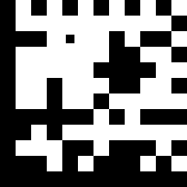
Example test symbol for Modulation
1.3 Symbols for Unused Error Correction
The figure below shows a Data Matrix ECC 200 symbol which encodes the data:
gibgibgibgibgibgibgibgibgibgibgibgibgibybiybiybiybiybiybiybiybi
it has had eight errors introduced by reversing the color of a single module in each of eight codewords in the data region. The symbol has 44 data codewords and 28 error correction codewords, giving an error correction capacity of 14 errors. The errors in the symbol yield an unused error correction value of 1 – 16/28 = 0.43, a value in the grade 2 range.
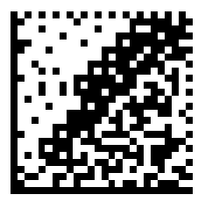
Test symbol for Unused Error Correction

1.4 Symbols for Fixed Pattern Damage and additional parameters
Since the evaluation of Fixed Pattern Damage varies for each symbology, and in some cases additional parameters are assessed, a separate test symbol is required for each symbology that the verifier is capable of verifying.
Example: test symbols for Data Matrix (ISO/IEC 15426-2) are defined. Figure shows a Data Matrix symbol with the following damage to each of the 5 segments:
Fixed Pattern Damage grading of Figure
Segment | Module errors | Grade
L1 | 2 | 3
L2 | 4 | 0
QZL1 | 4 | 2
QZL2 | 2 | 3
Clock track and adjacent solid pattern | 1 + 1 | 3
AG = 2.2 |  | 0
Therefore grade for Fixed Pattern Damage is 0

Data Matrix Test symbol for Fixed Pattern Damage
3.6 Recommended parameter values for test symbols
Table below illustrates the recommended range of values of the individual parameters which will meet the requirements stated above.

Parameter values for primary reference test symbols (matrix symbols)
Parameter | Grade 4 | Grade 2 | Grade 1
Symbol contrast | ≥ 73.75% |  | 25% ≤ SC ≤ 35%
Grid non-uniformity | ≤0.35 |  | 0.66 ≤ GNU ≤ 0.72
Axial Non-uniformity | ≤0.055 |  | 0.105 ≤ AN ≤ 0.115
Unused error correctiona | n/a | 0.43 | n/a
Fixed pattern damagea | AGb = 4 |  | AGb = 2.6
a These values apply only to Data Matrix symbols; corresponding values for other symbologies must be derived from the UEC or Fixed Pattern Damage grading basis used for the symbology in question
b AG refers to the average grade for the five Fixed Pattern segments evaluated for Data Matrix (see ISO/IEC 15415)

2. Normative references
The following normative documents contain provisions which, through reference in this text, constitute provisions of this statement of work. The latest edition of the referenced document applies.
ISO/IEC 15415 Information technology, Automatic identification and data capture techniques — Bar code symbol quality test specifications — Two-dimensional symbols
ISO/IEC 15426-2 Information technology — Automatic identification and data capture techniques — Bar code verifier specification — Part 2: Two-dimensional symbols
ISO/IEC 16022 Information technology — Automatic identification and data capture techniques — Bar code symbology specifications — Data Matrix
ISO/IEC 17962 Information technology, Automatic identification and data capture techniques — Harmonised vocabulary
AIM DPM-1-2006 Direct Part Mark (DPM) Quality Guideline

